Project

11 January 2020

Survey

1. Project Description

Design and implementation of a geospatial database containing all relevant information and data on the status of the sub-study area. The geospatial database will be supplemented with all spatial and descriptive data collected and will include procedures and functions for further spatial analysis. The data collection will include the number of social enterprises in the area, their areas of activity, the number of employees, support agencies etc. and will be updated throughout the project.

1. Deliverable

* Original Excel (ReceivedExcel.xlsx)
* Phase 3 processed excel with Latitude and Longitude (GeoLocations.xlsx)
* Application file (AGEMKO-master.zip)
* FinalSqlScript.sql
* [Site](http://consulting.apfse.eu/epixeiriseis/)

1. Implementation plan

In order to complete the project, the design and implementation of the project was divided into phases as shown below.

Phases

**Phase 1. An initial implementation plan was proposed after receiving the excel (ReceivedExcel.xlsx), which would create a complete database design from scratch (see below).**

Based on the original text provided, a geospatial database was designed that would include all the data needed to implement the project. The initial proposal was designed in MySQL, which is an open-source relational database management system (RDBMS). Based on the file and the data, the following database schema was designed as shown in Figure 1. The schema include 9 tables, with Businesses as the main table and all other tables are related to the above table with their keys as Foreign keys, except Representative table. Columns properties are as received from the excel file:

* Businesses (General Table)
* RegistryType
* IndividualCategory
* Status
* MainActivity
* Region
* RegionalUnity
* Municipality
* Representative

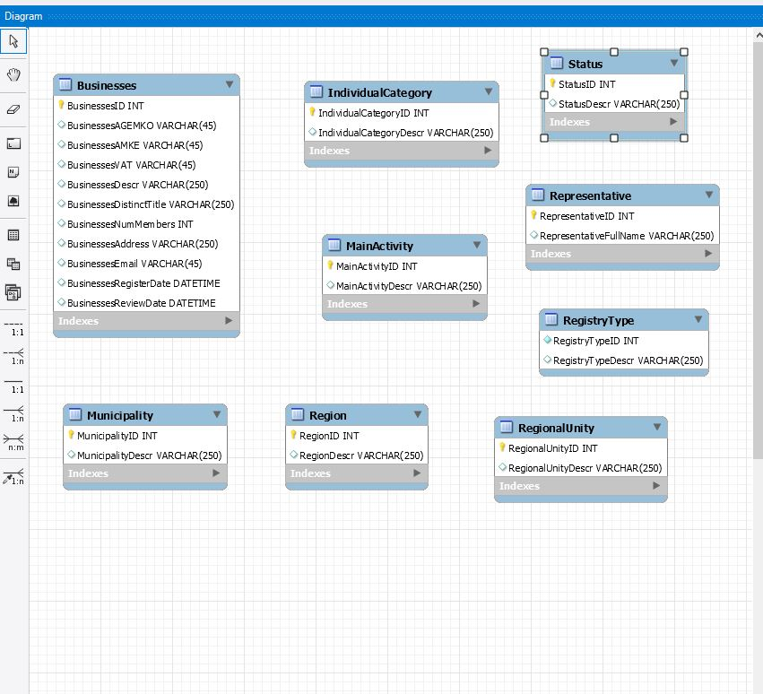

Figure 1. Proposed Database Schema.

**Phase 2**. Cancel Phase 1 due to the fact that the hosting [site](http://consulting.apfse.eu/epixeiriseis/) was already build in WordPress [site](http://consulting.apfse.eu/epixeiriseis/). The WP Google Maps Plug-In was proposed to purchase in order to support and show on the Google Maps the cooperating parties on the existing system. The WP Google Maps Plug-In allows us to create custom Google maps with high quality markers containing locations, descriptions, images, categories, links and directions as we needed.

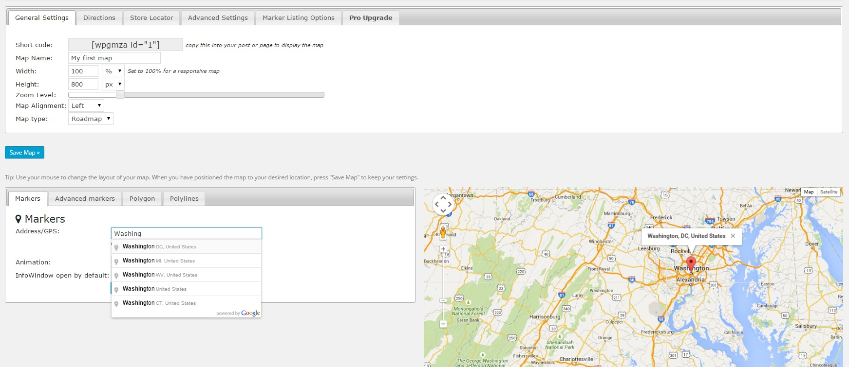

Figure 2. WP Google Maps Plug-In template.

**Phase 3**. Perchance (WP Google Maps Plug-in) to support and customized Google Maps on the existing page.

**Phase 4.** Due to the absence of some primary data like Latitude and Longitude that were that were needed for the WP Google Maps Plug-in. Additional process to the primary file needed to be completed. In order to receive the Latitude and Longitude the primary file needed to be converted to a google spreadsheet and be formatted to the appropriate style in order to use Mapping Sheets add-on and retrieve Latitude and Longitude of the file data. The Mapping Sheets add-on provides an easy way to process the data directly from Google Sheets onto a map, either to show each location details in an Info window or for filtering over the map based on several conditions, but also to find locations within a distance to a place and ultimately to calculate the optimal route directions see Figure.3, 4, 5.

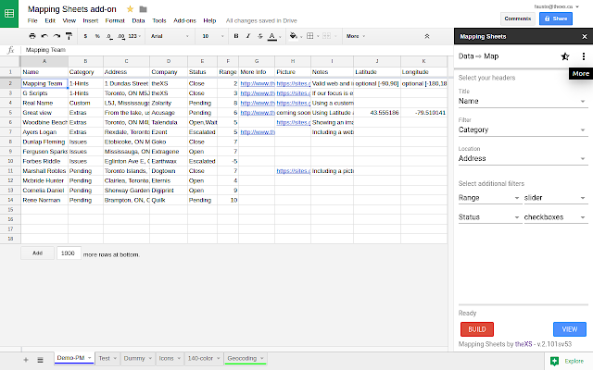

Figure 3. Mapping Sheets Add-on template

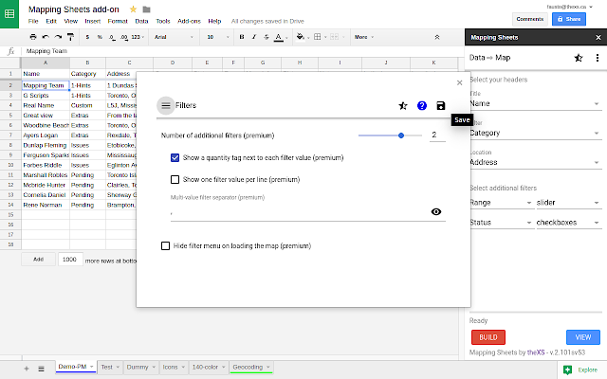

Figure 4. Mapping Sheets Add-on template

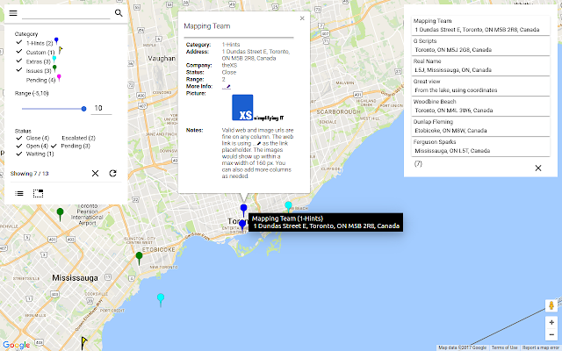

Figure 5. Mapping Sheets Add-on template

**Phase 5.** A C# Console application was created in order to process and properly format the data that were exported from the Mapping Sheet Add-on in order to be executed to the WordPress database. The above program works as follows: The program receives as input file the processed file from the Mapping Sheet Add-on, then it formats the data to the appropriate format that the WP Google Maps Plug-in needs and exports a sql file. The exported file is the executable file that will be executed to the WordPress database of the site see Figures 6, 7, 8, 9. Show a sample of the C# program and the Figure 10 shows the exported file with the appropriate format.

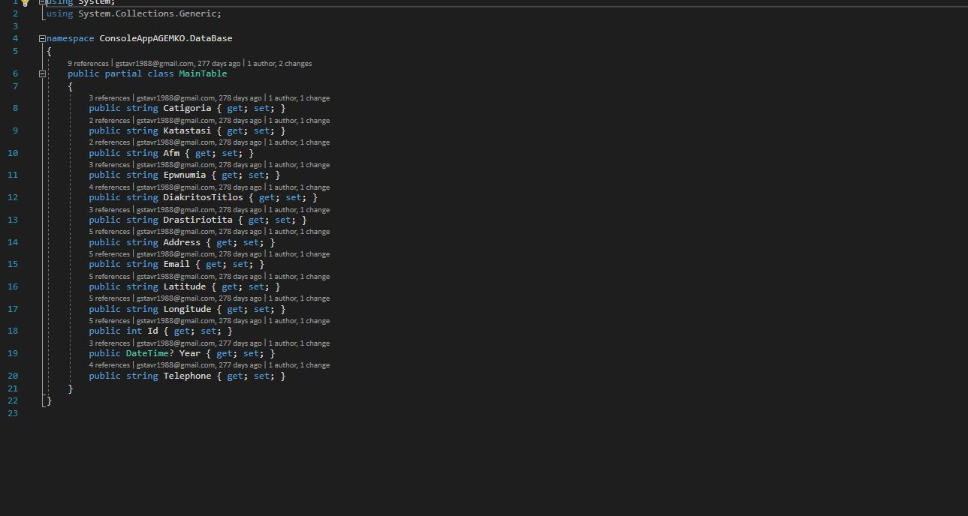

Figure 6. Main Table Class.

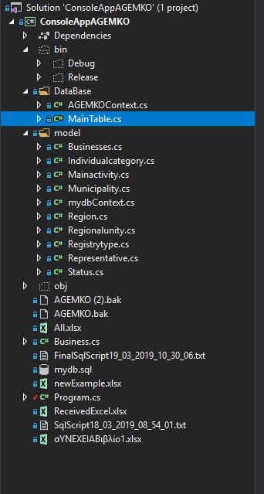

Figure 7. Project Solution Tree

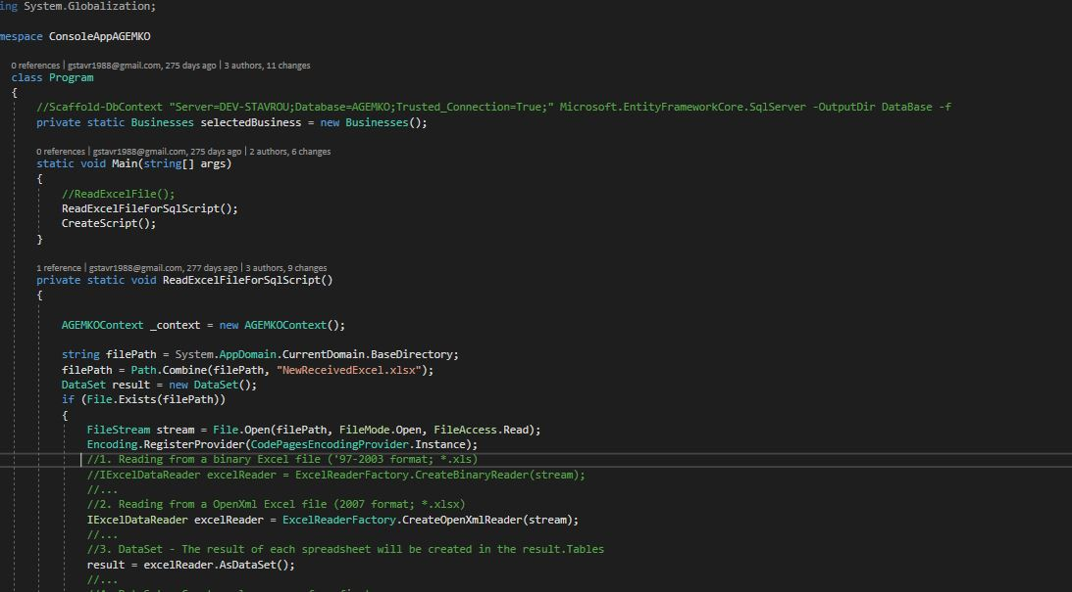

Figure 8. Main C# code

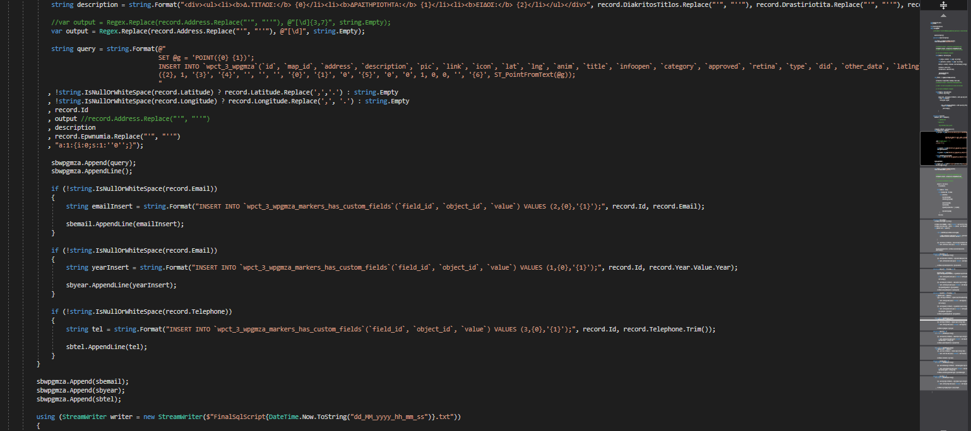

Figure 9. WP Google Maps Format and export

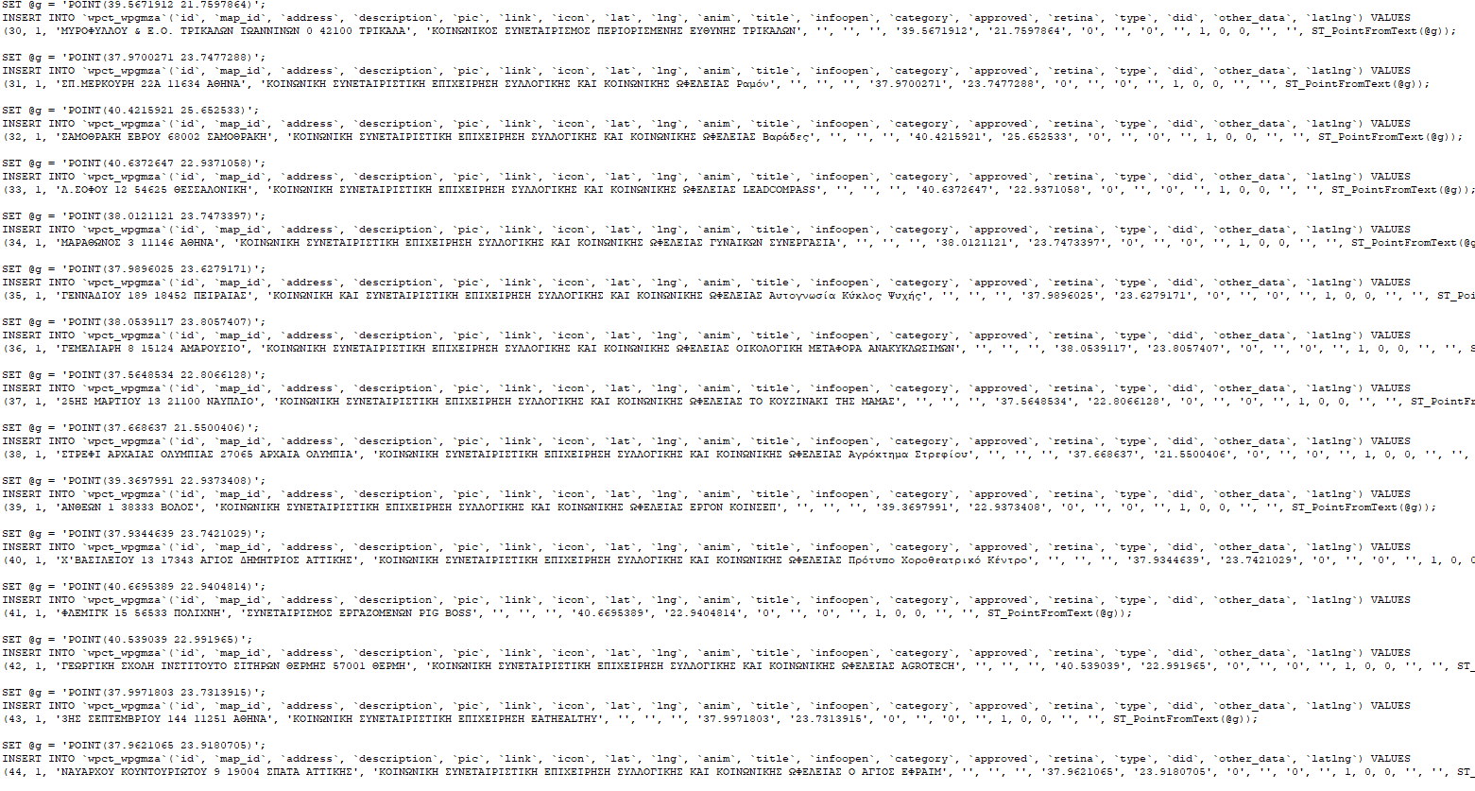

Figure 10. Formatted data

**Phase 7.** The exported file as show above is executed to the WordPress database of the site (FinalSqlScript.sql) in order our data to be show to the WP Google Maps Plug-In and in our [site](http://consulting.apfse.eu/epixeiriseis/) as show in Figures 11, 12, 13.

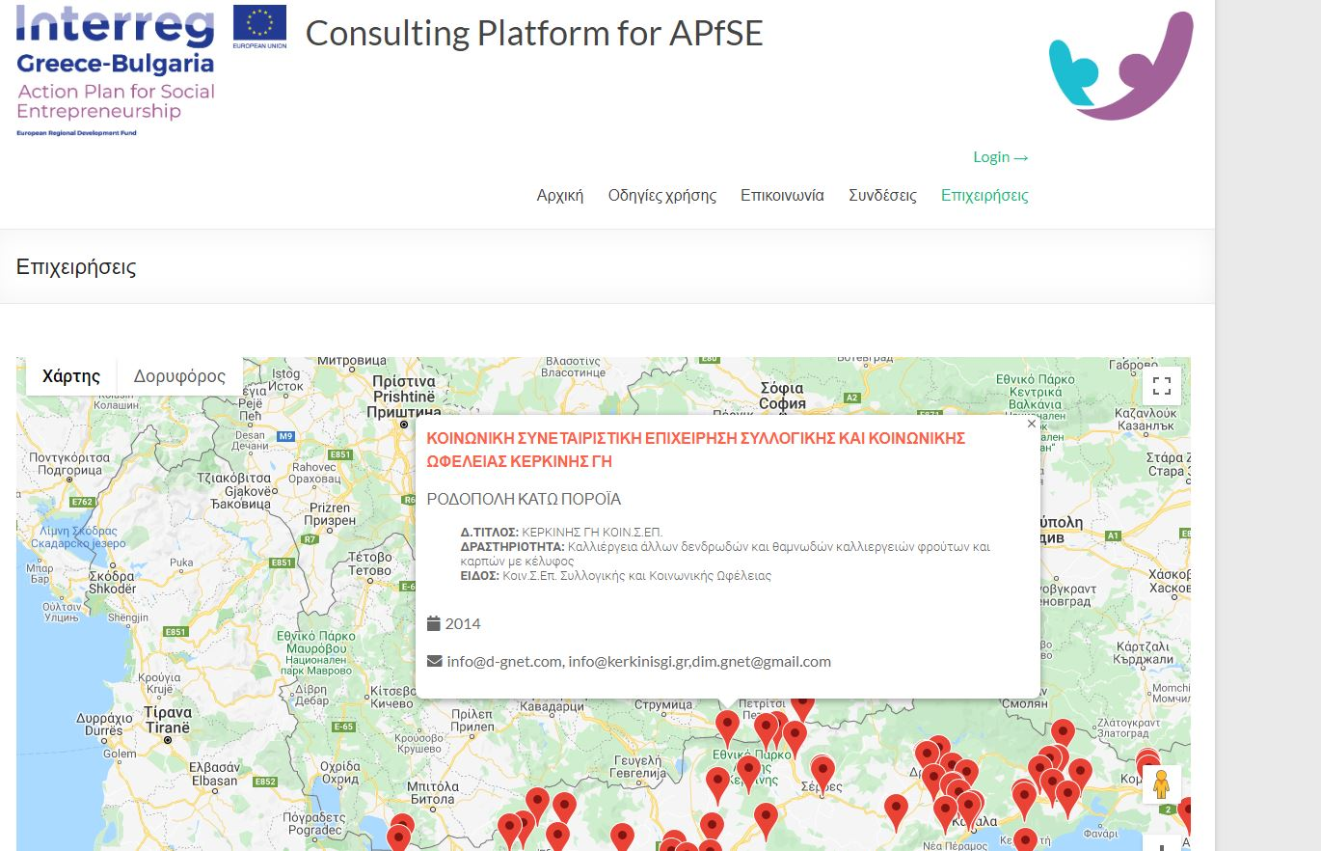

Figure 11. Company Information at <http://consulting.apfse.eu/>

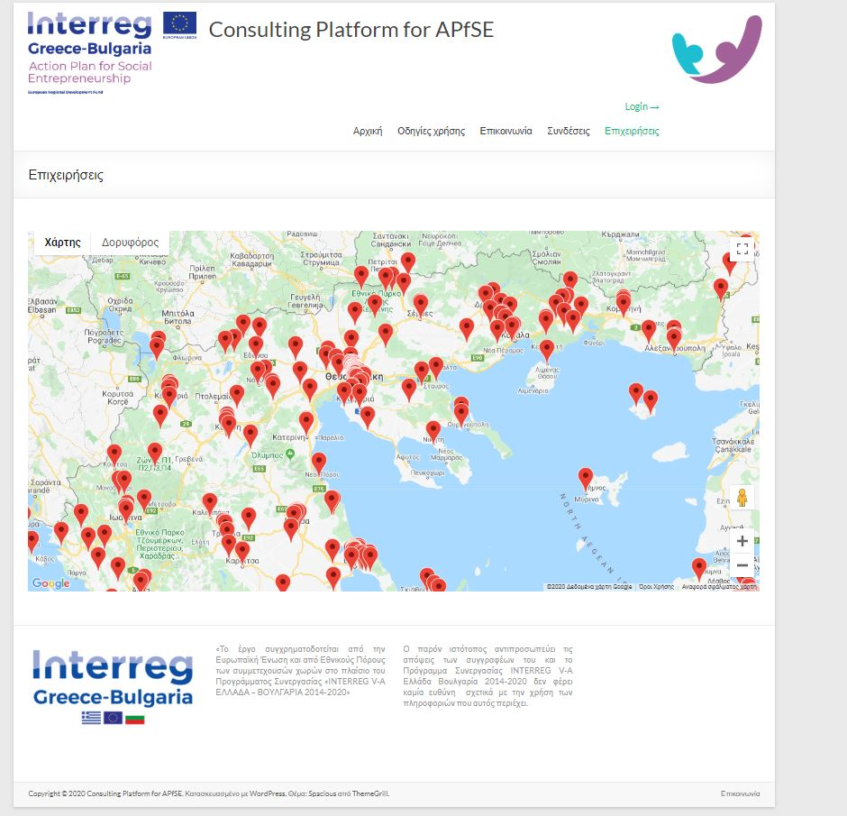

Figure 11. Makers in WP Google Maps Plug-in at <http://consulting.apfse.eu/>

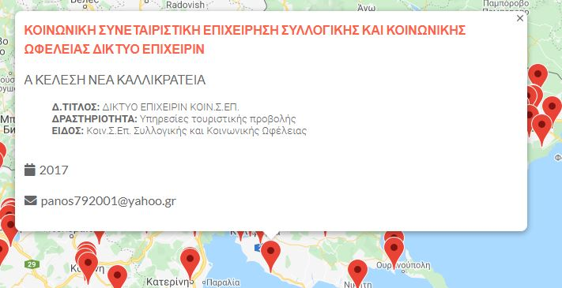

Figure 12. Company information in WP Google Maps Plug-in at <http://consulting.apfse.eu/>